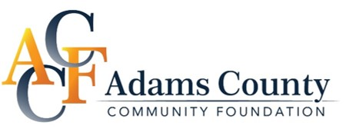

GIVING for A LIVABLE COMMUNITY

Anonymous giving: Contact John Heinen, NDCF Dickinson Office at (701) 590-4614 or John@NDCF.net

Contact Information:
Name
Address
City State Zip
Phone
I prefer to be contacted via phone or e-mail E-mail

By Check:
Gift for Endowment $____________________ for Project non-endowment $______________________
***Separate checks should be written if giving to both funds--write Adams County Endow, or Adams County Project on the memo line.
We would like a pledge reminder (gifts over $5,000) We would like to be listed anonymously
We would like to be acknowledged as
This gift is in honor/memory of
We would like to pay this amount in full $
We would like to pay $ now and $ Annually Semi-Annually
Quarterly

Mail to: NDCF C/O ACCF- Adams County Community Foundation PO Box 387 Bismarck, ND 58502-0387
OR Online Securely at NDCF.net/AdamsCounty (can be changed at anytime)
- Allows automatic giving
- Memorials naming
- List as Anonymous
- Give to Project and/or Endowment

Gift Amount | Quarterly (4) PMT | Monthly (12) PMT | For Endowment Only | Pledge reminders endowment or Project Fund
$50 | $12.50 | $4.16 | Corporate ND Tax Credit Available up to $25K gifts | N/A
$100 | 25 | 8.33 |  | N/A
$250 | $62.50 | $20.83 |  | N/A
$500 | $125 | $41.66 |  | N/A
$1,000 | $250 | $83.33 |  | N/A
$2,500 | $625 | $208.33 |  | N/A
$5,000 | $1250 | $416.66 | Individual ND Tax Credit Available $25K individual max, $50K per couple max | Via email
$10,000 | $2500 | $833.33 |  | Via email
$15,000 | $3750 | $1250 |  | Via email

